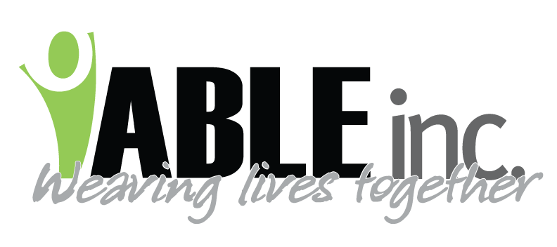
WEST RIVER COMMUNITY CENTER DISCOUNT:
As a full or part-time employee of ABLE, Inc. you are eligible to purchase an annual package at the West River Community Center at a reduced corporate rate. The corporate rate is 15-20 percent off the regular annual prices. If you decide to sign-up for an annual package, let the Dickinson Parks & Recreation clerk know that you are employed at ABLE, Inc. They will set up your payment plan and verify your employment with ABLE, Inc. at that time. (Officials from the Park and Recreation office have stated that you may discontinue your annual membership at anytime, but there will be a $25.00 fee to process this change.) If you have any questions, please contact the business office at ABLE, Inc.'s main office at 456-3000; or you may call the Park and Recreation offices directly at 456-2074.

VERIZON WIRELESS DISCOUNT:
All ABLE, Inc. employees are eligible to receive a 19% or 22% discount off the monthly recurring charges through Verizon Wireless. You will receive a 19% discount for paying by mail and 22% discount for paying online. You will need to go through an enrollment process in order to become eligible and then renew each year. There are different directions depending if you have Microsoft Office Outlook email at work or not.

  - If you have an Microsoft Office Outlook Email:
Go to www.verizonwireless.com/discount
Under Check Your Eligibility enter your work email and confirm
Click Check for Discounts
Continue filling out information
If you are not the primary holder of the account you will need the person's name and last four digits of their social security number.
  - If you do NOT have Microsoft Office Outlook Email:
Go to www.verizonwireless.com/discount
Under Check Your Eligibility: Next to the Check for Discount button click Don't have a work email address.
Under Current Verizon Wireless Customer click Employment Validation Form
Put in your information - including personal email
You will need to put Employer Information:
ABLE Inc (Do not put a comma after ABLE)
1951 1st Street West
Dickinson ND 58601
You will either need to scan a copy of your paystub (black out any unnecessary information) or mail in a copy.
If you are mailing in a copy, hit the Send a Copy of paystub by mail button.
If you scanned a copy, then continue - browse and upload.
It will say upload successful and you will receive an email in 3-5 days.

- Employee Value or Discount: Discount of 22% (19% + 3% bonus when enrolling in paperless billing) off the monthly recurring charges. Discount applies to any generally available voice and data calling plan with a monthly access plan of $39.99 or higher, unless such plan specifies that discounts are not applicable. The discount will be applied to the subscriber bill. Discounts will take two billing cycles to appear on the subscriber bill.
The data feature discount is 22% and applies to any generally available Verizon Wireless Data Feature with a monthly access of $24.99 or higher, added to an eligible calling plan that doesn’t prohibit discounts.
The discount for accessories is 25%.
Upon an executed Verizon Wireless Member Agreement, by the facility where the employee works, the employee is able to procure discounted service and phones under individual personal liability through the following channels. To begin the process, please visit the employee extranet at www.verizonwireless.com/discounts. Employees who do not have internet access may contact Verizon Telesales at 888-386-4339 to order services.
NOTE: Employee family members can access the program as well, provided the employee assumes financial liability.

TRAVEL EMPLOYEES - WEST RIVER COMMUNITY CENTER DISCOUNT:

As a travel staff with ABLE, Inc. you are eligible to purchase a package at the West River Community Center at a reduced corporate rate. The corporate rate is 15-20 percent off the regular prices. If you decide to sign-up for a package, let the Dickinson Parks & Recreation clerk know that you are working at ABLE, Inc. They will need to see a copy of your contract, showing the contract dates.

If you wish to discontinue your membership, you will need to contact WRCC to stop automatic payment arrangements prior to leaving Dickinson. They typically charge a $25 fee to process cancellations but this may be discussed to see if they will forgive the $25 fee at the time of cancellation due to you moving.

If you have any questions, please discuss with your supervisor or you may call the Park and Recreation office directly at 456-2074.

